<https://yamvacationrentals.com/landing-yachts/>

Menu sticky

**LOGO PERSONALIZED ATTENTION IN ENGLISH, SPANISH, AND HEBREW (786) 354-0131**

**YOUR SOUTH FLORIDA DREAM LUXURY VACATION HOME IS WAITING FOR YOU**

**GET A FREE QUOTE NOW**

As seen on

**[LOGO] [LOGO] [LOGO] [LOGO] [LOGO]**

| [FOTO] | **HAVE THE VACATION OF YOUR LIFE WITH US**  Yam Vacation offers Waterfront luxury vacation houses, luxury villas, and mansion rentals. Enjoy exceptional service at the highest standards, and create unforgettable memories with your loved ones on one of our top-of-the-vacation-rentals.  On top of that, all of our guests enjoy:   * 24/7 Concierge Service * Luxury Fully-equipped houses * Modern Luxurious Design * Crazy attention to detail * Quality above expectations * Top-notch amenities * Top locations around South Florida * Gorgeous water views |
| --- | --- |
| **FIND OUT MORE** |

**IMAGINE THE LUXURY YOU’LL EXPERIENCE**

| **PHOTO**  **HOUSE 1** | **PHOTO**  **HOUSE 2** | **PHOTO**  **HOUSE 3** | **PHOTO**  **HOUSE4** |
| --- | --- | --- | --- |
| **PHOTO**  **HOUSE 5** | **PHOTO**  **HOUSE 6** | **PHOTO**  **HOUSE 7** | **PHOTO**  **HOUSE 8** |

**VIEW OUR INVENTORY**

| **TOP OCEAN FRONT VACATION DESTINATION**  **IN USA**  South Florida, USA, boasts a warm and tropical environment all year round. It has the most beautiful, pristine white sand beaches, and the Intracoastal waterway canal which makes it a prime luxury destination spot.  It is also a land rich in cultural diversity, fun activities, top-notch amenities, Latin vibes, and award-winning restaurants.  So, are you ready to splurge and stay at one of the best luxury vacation home rentals in one of our exclusive properties in Fort Lauderdale, Hollywood, Aventura, or Sunny Isles? | [FOTO] |
| --- | --- |
| **BOOK YOUR TRIP NOW** |

**ALL YOUR RENTALS INCLUDE**

| **ICONO** | **ICONO** | **ICONO** |
| --- | --- | --- |
| 24/7 CONCIERGE SERVICE WITH YAM VIP SERVICES | WATERFRONT HOUSES ON TOP LOCATIONS | FULLY EQUIPED WITH LUXURY APPLIANCES |

## BUT DON’T JUST TAKE OUR WORD FOR IT…

#### Hear what our clients had to say after cruising with us.

| “Urna sit ipsum amet pellentesque amet. Vestibulum in porta enim vitae quam etiam. Nunc sapien vitae sit sodales. Pretium hac aliquam ipsum tincidunt habitant nisl risus. Tristique interdum in elementum.” | “Urna sit ipsum amet pellentesque amet. Vestibulum in porta enim vitae quam etiam. Nunc sapien vitae sit sodales. Pretium hac aliquam ipsum tincidunt habitant nisl risus. Tristique interdum in elementum.” | “Urna sit ipsum amet pellentesque amet. Vestibulum in porta enim vitae quam etiam. Nunc sapien vitae sit sodales. Pretium hac aliquam ipsum tincidunt habitant nisl risus. Tristique interdum in elementum.” |
| --- | --- | --- |
| **\* * * * \*** | **\* * * * \*** | **\* * * * \*** |
|  |  |  |
| Guy Hawkins Delaware | Jeff Cohen California | Elisheva Poler New York |

| [FOTO] | **WHAT YOU CAN EXPECT**   * Top Locations in South Florida * Modern Luxurious Houses * Fully-equipped houses * Gorgeous water views   Don’t just take a vacation, create the memories of your life with your family and friends in any of our distinguished homes.  Experience Stress-free vacations in luxury mansions with concierge services with tons of activities such us yacht rentals, wave runners, luxury car rentals, personalized catering, yoga classes and much more. |
| --- | --- |
|  | **SPEAK TO AN AGENT NOW** |

## STILL HAVE QUESTIONS? WE HAVE ANSWERS…

#### Or if you’re wondering about something not covered below, call us on +1 (786) 354-0131‬ or reservation@yamvacationrentals.com, and we’ll get back to you as soon as we can!

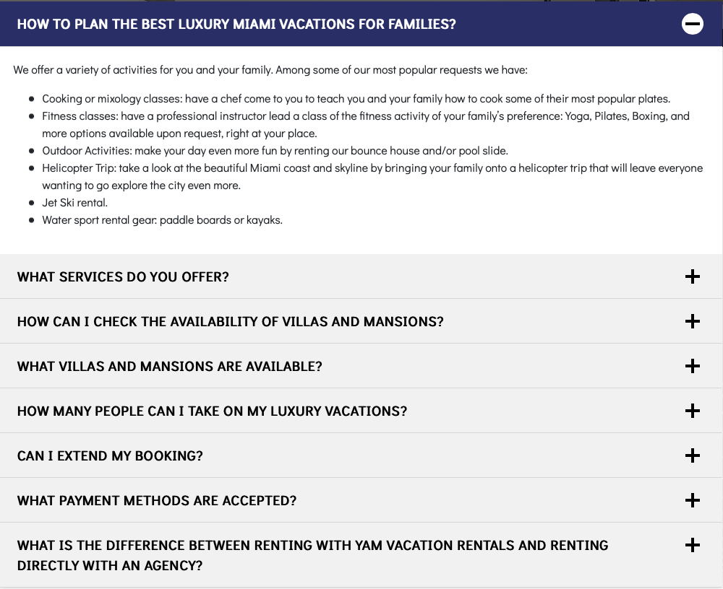

| TELL US WHAT YOU WANT AND ONE OF OUR TRAVEL SPECIALISTS WILL GET BACK TO YOU.  OR IF YOU PREFER, CALL US AT (786) 354-0131, YOU WILL RECEIVE PERSONALIZED ATTENTION  WE SPEAK  ENGLISH, SPANISH OR HEBREW | NAME LAST NAME  EMAIL PHONE  RENTAL DATE #OF DAYS  * TOTAL # OF GUESTS # KIDS UNDER 12  ADDITIONAL INFORMATION  * Infants don't count toward the number of guests. |
| --- | --- |

Copyright © 2022 - YAM Vacations Rentals - [Privacy Policy](https://yamvacationrentals.com/privacy-policy)

DEVELOPED BY [SMG](http://www.screenmediagroup.com/) | [DIGITAL MARKETING AGENCY](http://www.screenmediagroup.com/)